Grdaed Lab 01
Code
import java.util.Scanner;
class PredictionEngine {
private int numberOfPeople;
private double processingFactor;
public PredictionEngine(int numberOfPeople, double processingFactor) {
this.numberOfPeople = numberOfPeople;
this.processingFactor = processingFactor;
}
public int getNumberOfPeople() {
return numberOfPeople;
}
public void setNumberOfPeople(int numberOfPeople) {
this.numberOfPeople = numberOfPeople;
}
public double getProcessingFactor() {
return processingFactor;
}
public void setProcessingFactor(double processingFactor) {
this.processingFactor = processingFactor;
}
public double compute() {
return numberOfPeople * processingFactor;
}
}
public class Task1 {
public static void main(String[] args) {
Scanner input = new Scanner(System.in);
System.out.print("Enter number of people in queue: ");
int people = input.nextInt();
System.out.print("Enter desk processing factor: ");
double factor = input.nextDouble();
PredictionEngine engine = new PredictionEngine(people, factor);
double predictedTime = engine.compute();
System.out.println("Predicted Waiting Time: " + predictedTime + " minutes");
if (predictedTime < 10) {
System.out.println("Advisory: Short wait, proceed normally.");
} else if (predictedTime < 30) {
System.out.println("Advisory: Moderate wait, plan accordingly.");
} else {
System.out.println("Advisory: Long wait, consider coming later.");
}
input.close();
}
}
Output
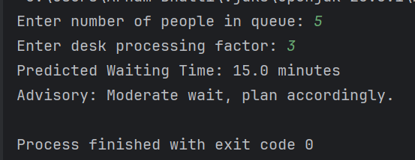

Functional Requirements
1)Students will be able to join a queue by scanning a QR code on the system.
2)Each student will receive a unique QueueToken from the system.
3)Every service desk's real-time queue length will be monitored by the system.
4)The anticipated waiting time will be determined by the system using:
5)Number of people × desk processing factor equals predicted time.
6)Students will see an estimated waiting time displayed by the system.
7)Admins will be able to manually override anticipated wait times through the system.
8)In an emergency, the system will enable security personnel to force-clear lines.
9)For auditing purposes, the system must record every action (join, override, clear queue).
Non-Functional Requirements
Performance:
The queue status and forecasts should be updated by the system in real time with the least amount of delay (less than two seconds).
Integrity of the Audit:
Every system action needs to be safely recorded and impenetrable.
Control of Access:
Queues can only be changed or cleared by authorised users, such as administrators and security personnel.
Error Transparency:
Clear error messages (such as "invalid token" or "system failure") must be provided by the system.
Use Case Diagram
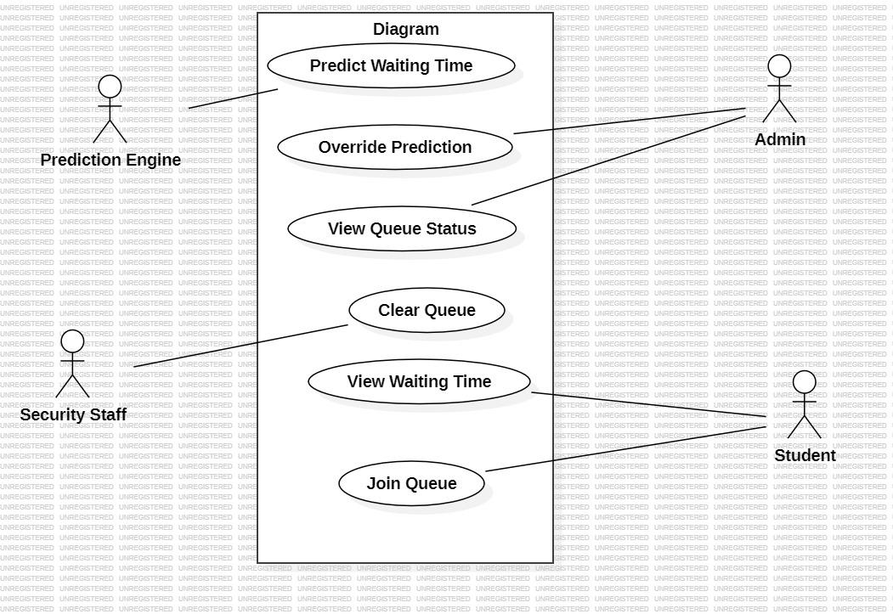

Class Diagram
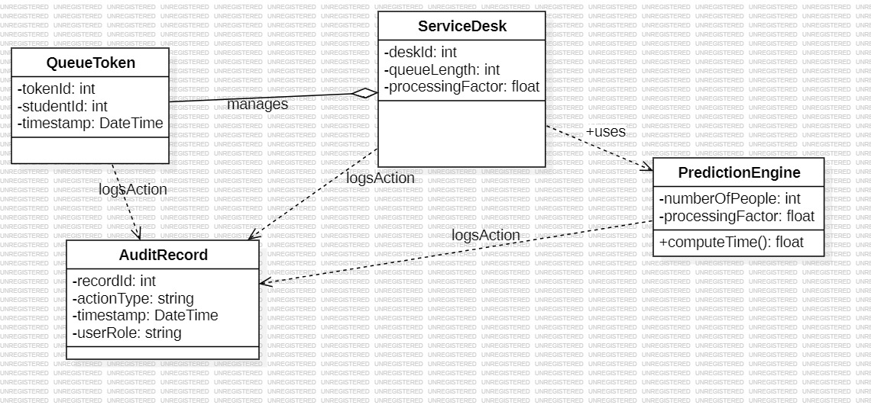
Sequence Diagram
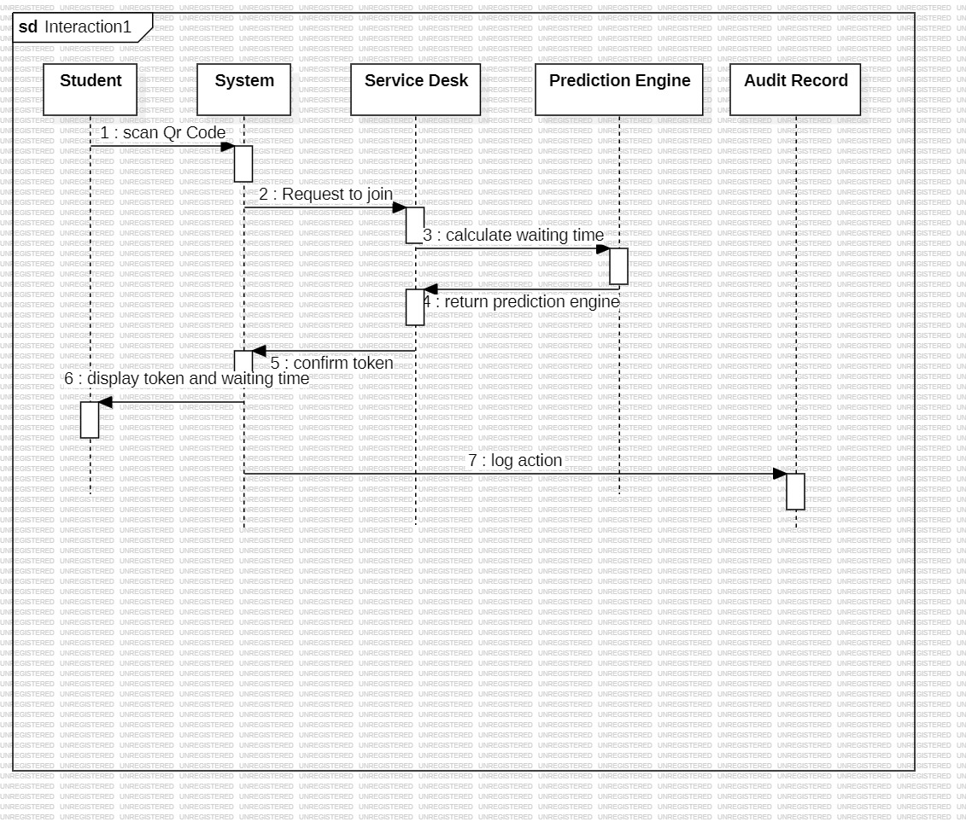
Section c

